[WIP] Homework Assignment 2: Order Management
- Objective
Implementing an application that has a graphical user interface to allow communication to a database
- Context
Using the structure DB → DAL → BLL → Controller → View (some → are the model)
- Design
Data Acess Layer
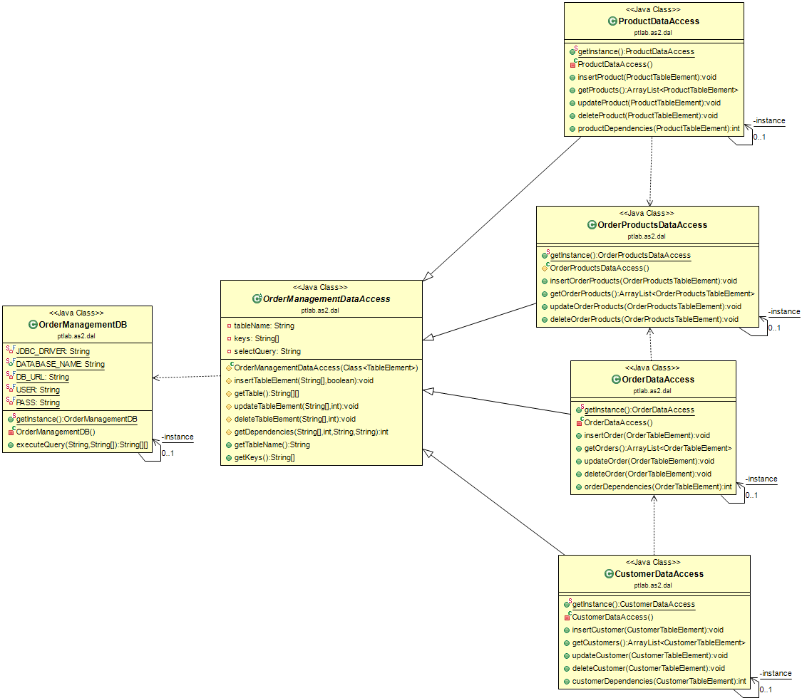
Business logic level
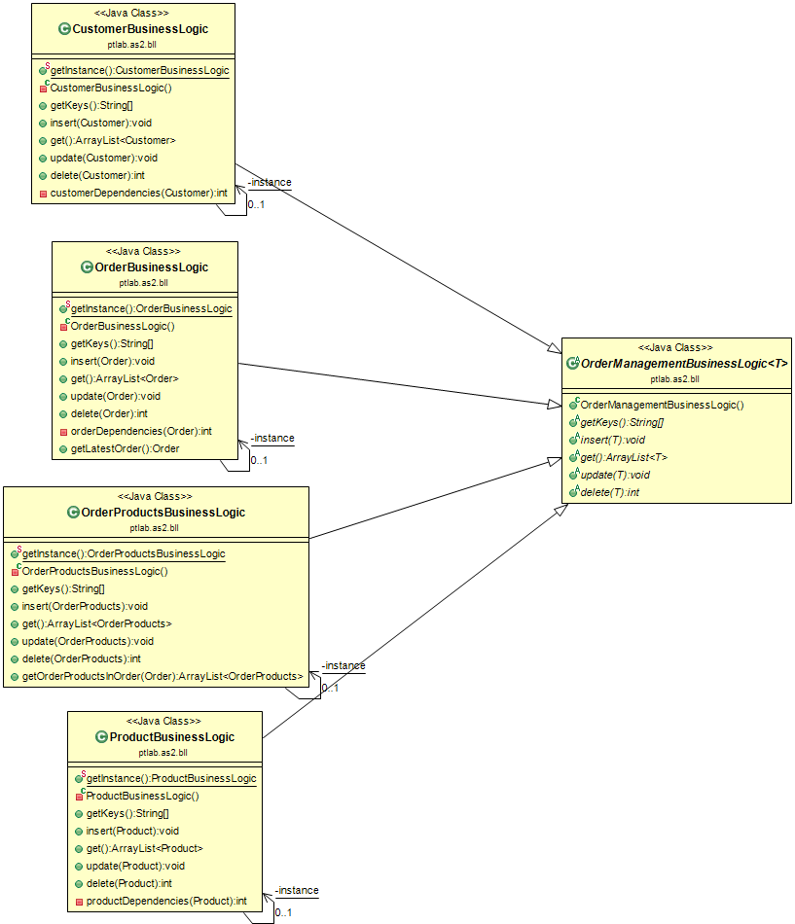
Data Access Layer connected to Business Logic Level
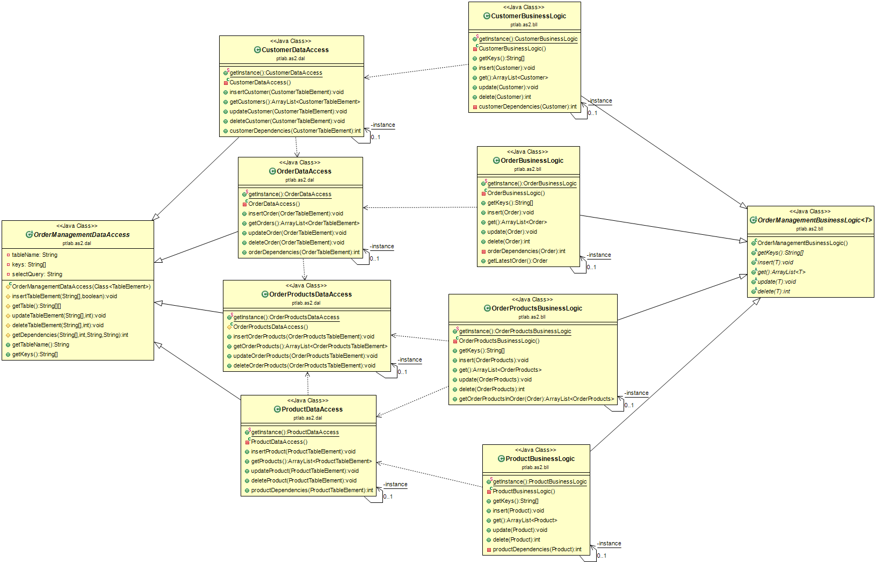
Table Element model classes
These classes are used as a bridge between Data Access Layer and Business Logic Layer
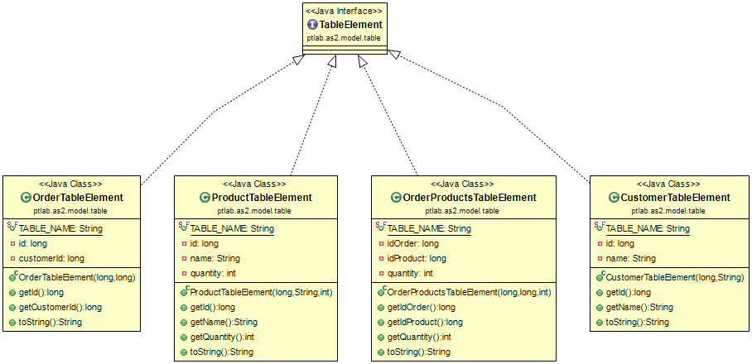
Data Access Layer and Business Logic Layer connected by Table Elements
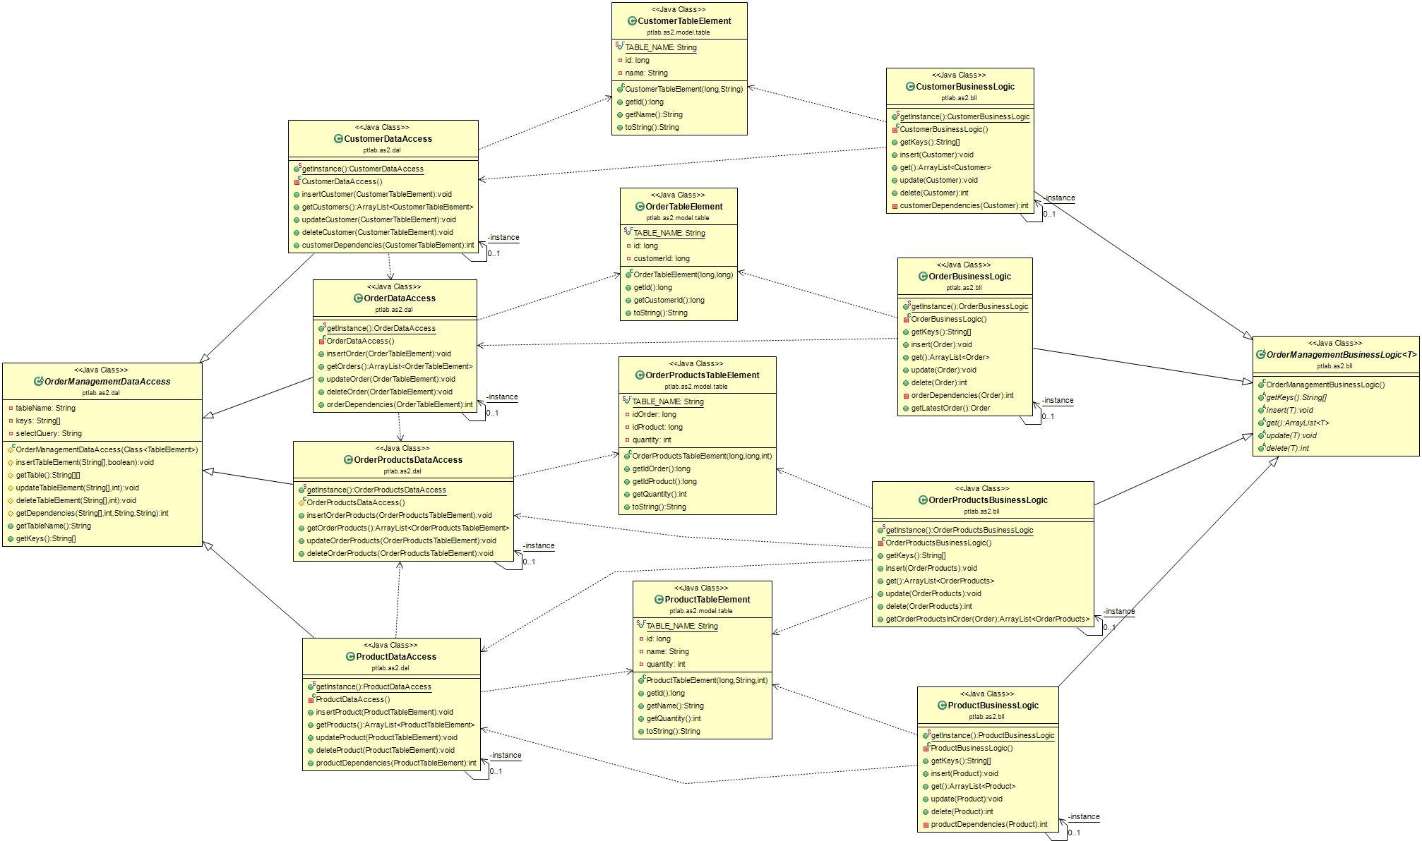
Model element classes
Used to connect the Business Logic Layer and Controller
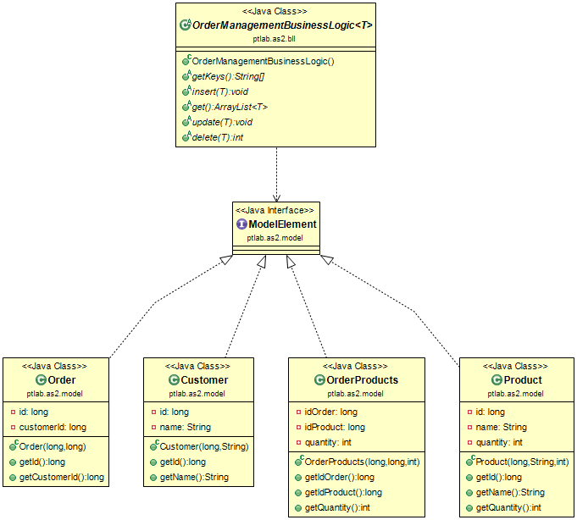
Data Access Layer – Business Logic Layer with complete model
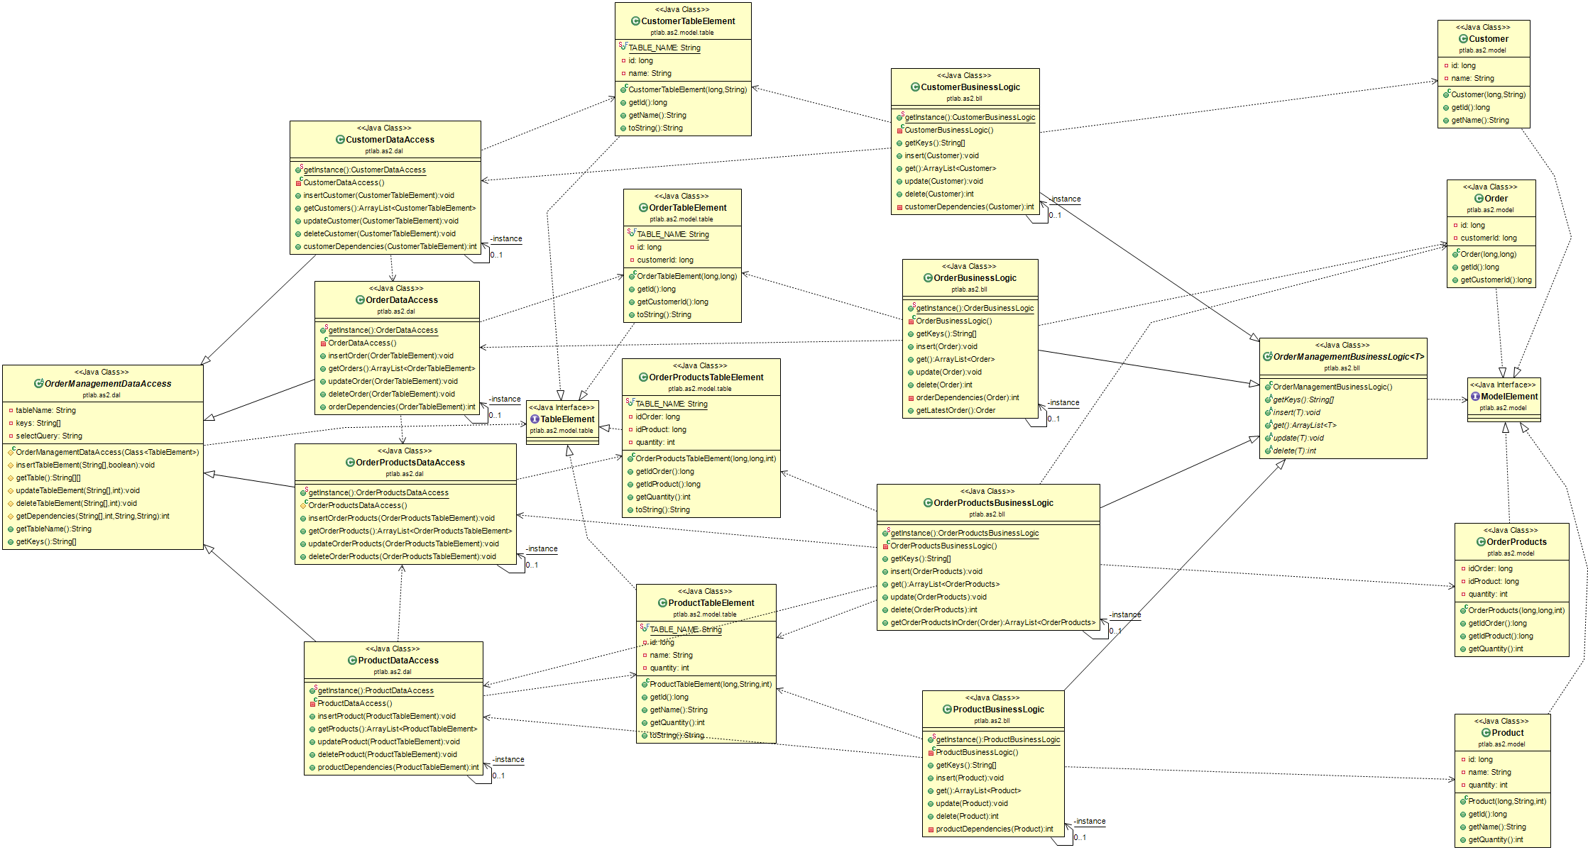
Controller
This section treats controllers separately (independent form the rest of the project) to reveal their structure
Is a holder for the controllers regarding each operation department
- Customer Controllers
- Product Controllers
- Order Controllers
- Stock Controller

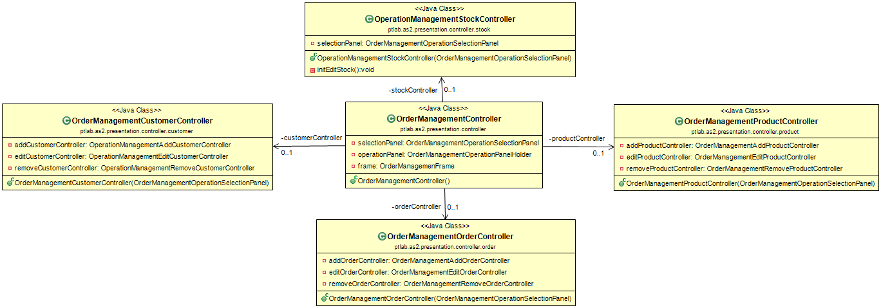
Customer Controller
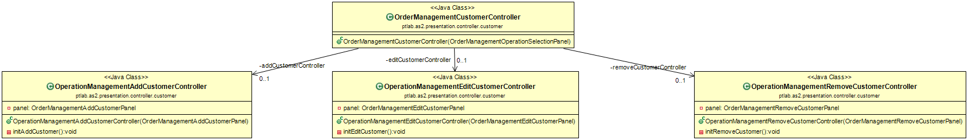
Customer Controller with inner classes
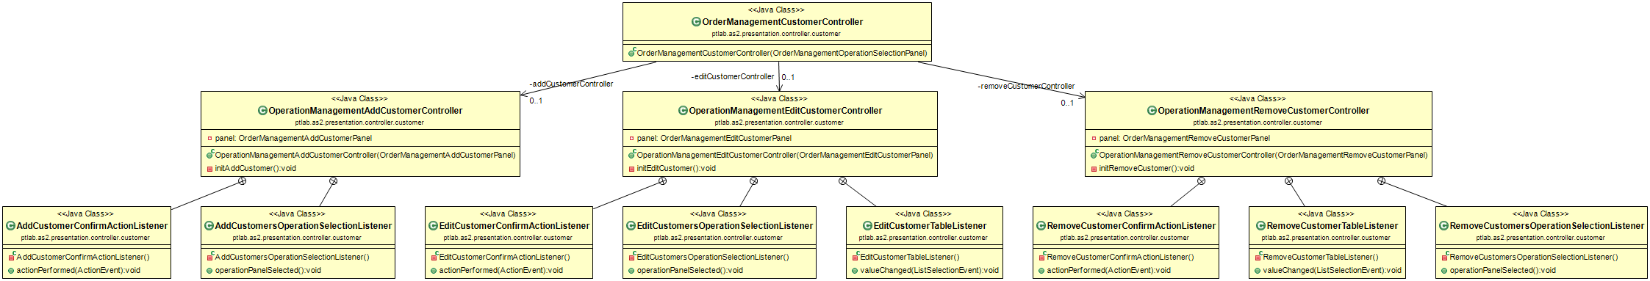
Product Controller
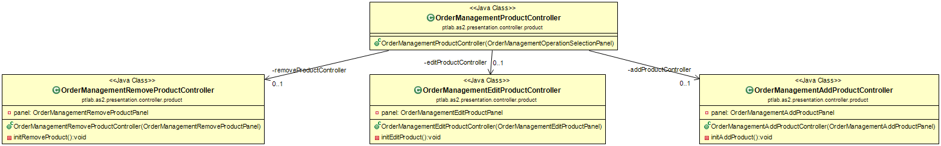
Product Controller with inner classes
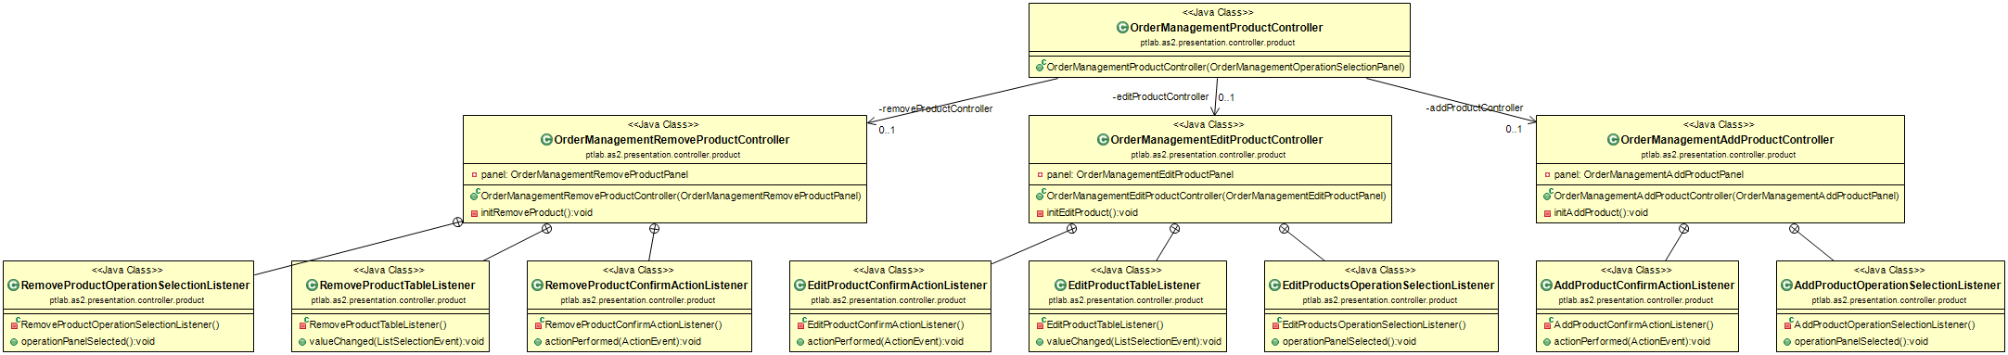
Stock Controller
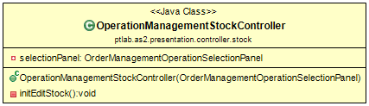
Stock Controller with inner classes
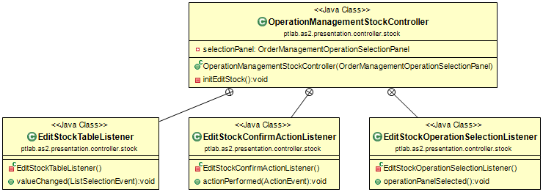
Order Controller
Order Controller with inner classes
Controllers – all classes
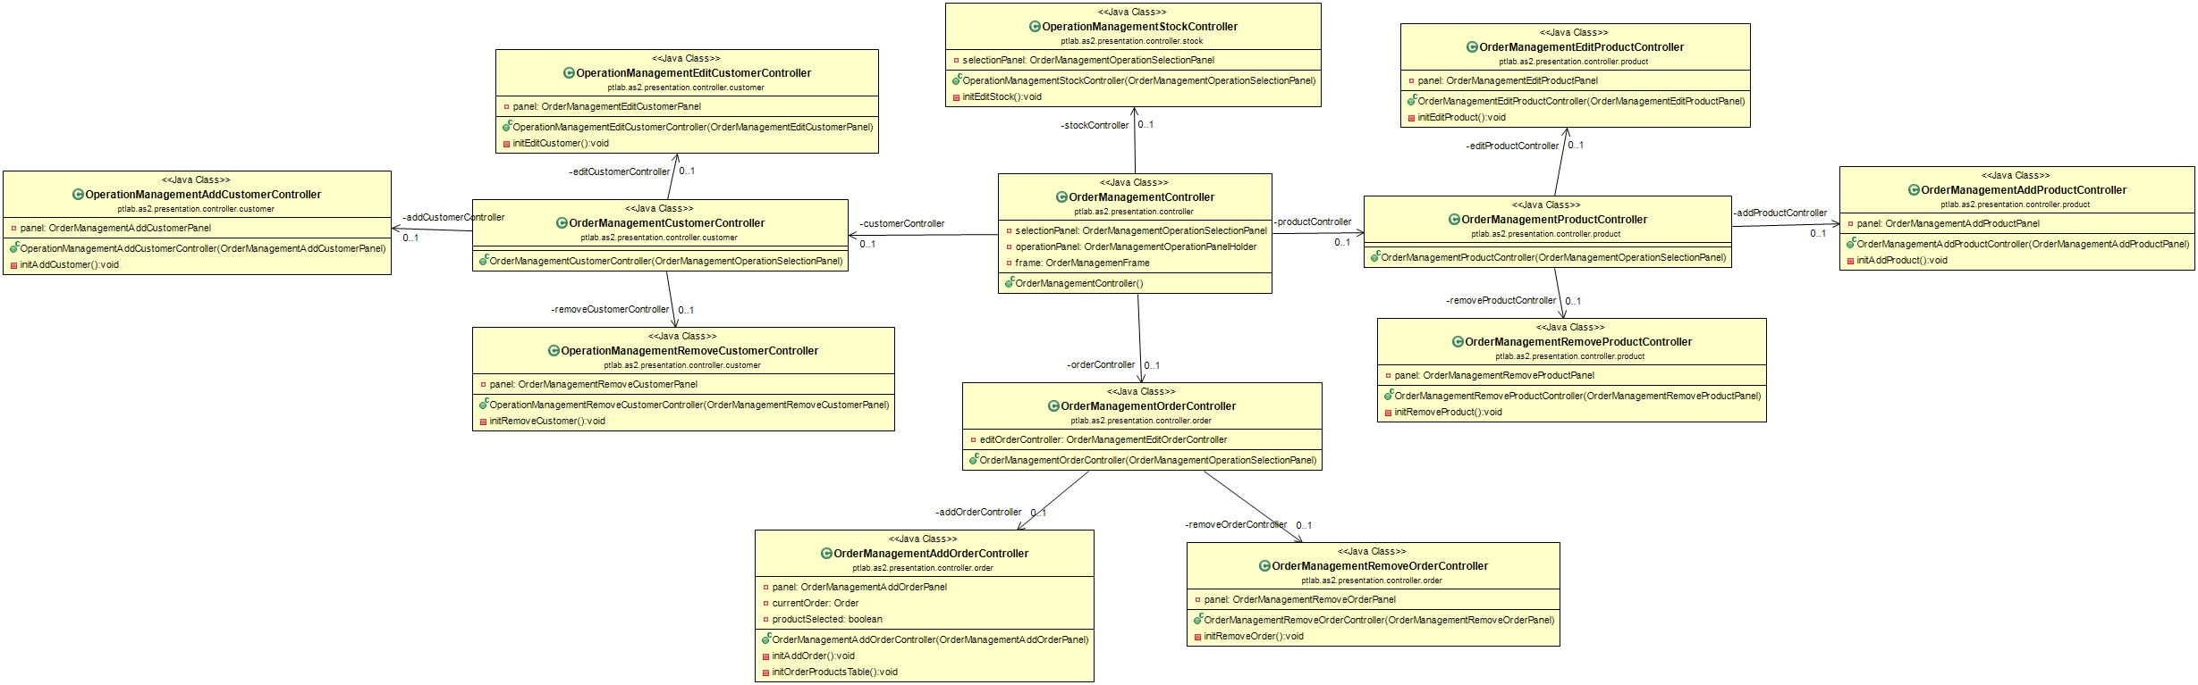
Controllers - everything
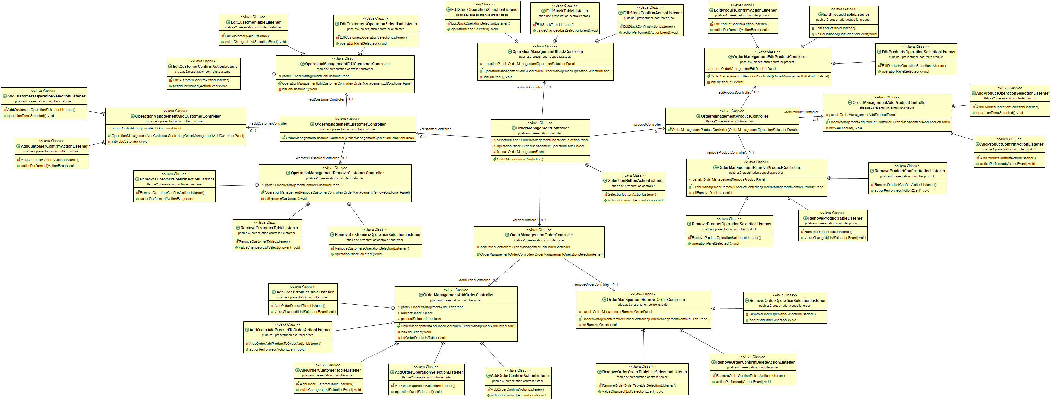
Views – this section presents views separately, to reveal their structure

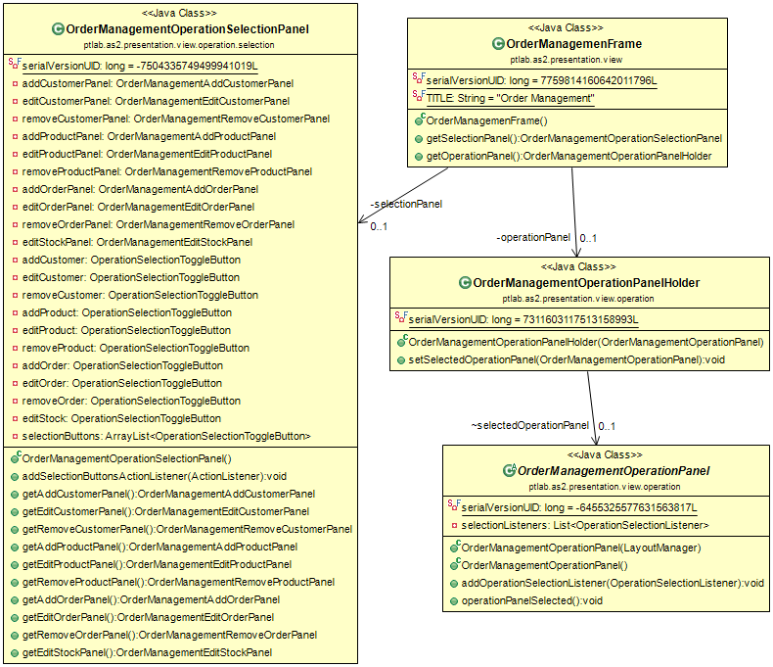
View Full
